Project 4 Day 2

Business Question 1:
Query 1: Total Revenue
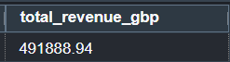
The analysis shows that UrbanShift generated approximately £491,881 in revenue over the nine-month analysis period.

Query 2: Revenue by Customer
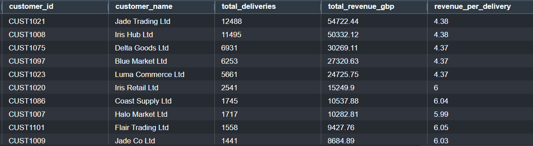
Jade Trading Ltd and Iris Hub Ltd generating the highest total revenue. These customers also account for a large proportion of delivery activity. This suggests UrbanShift relies heavily on a small number of key customer accounts. Losing even one of these customers could have a significant impact on business performance.
Revenue per delivery remains relatively consistent across the highest-value customers, suggesting that differences in revenue are primarily driven by delivery volume rather than higher-value deliveries.

Query 3: Revenue by Customer Size Segment
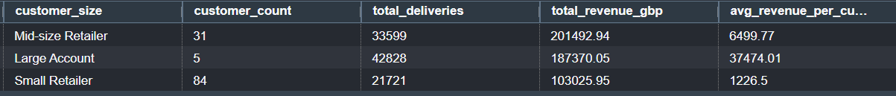
Mid-size retailers generated the highest overall revenue (£201,492.94), followed by Large Accounts (£187,370.05). However, Large Accounts generated substantially higher revenue per customer (£37,474.01), reflecting their higher individual commercial value despite representing only five customers.
This indicates that while mid-size retailers collectively contribute most revenue, retaining large accounts remains commercially critical.

Query 4: Revenue by Industry
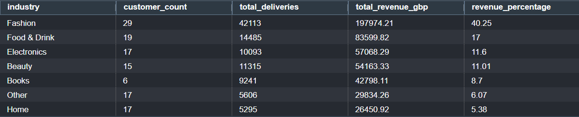
The Fashion industry contributes 40.25% of total revenue, significantly exceeding every other sector. Food & Drink contributes 17%, while Electronics contributes 11.6%.
This indicates that UrbanShift is heavily dependent upon the Fashion sector, making performance within this industry particularly important for overall business success.

Query 5: Revenue by City
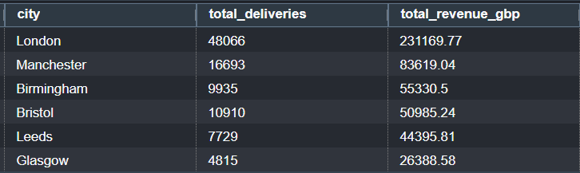
London generates the highest revenue (£231,169.77), representing almost half of total company revenue. Manchester ranks second, followed by Birmingham, Bristol, Leeds and Glasgow.
This largely reflects delivery volume rather than operational efficiency, as London also records the largest number of deliveries.

Query 6: Monthly Revenue Trend
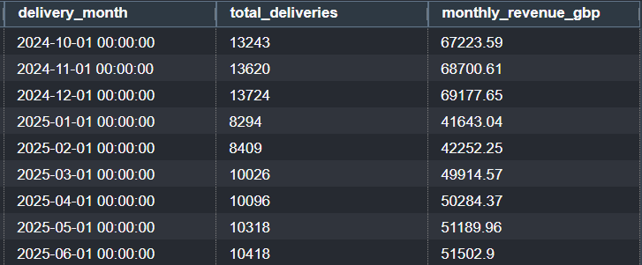
Revenue remains relatively stable between October and December before declining noticeably during January, followed by a gradual recovery during the remaining months.
This pattern suggests seasonal demand, likely influenced by increased parcel volumes during the Christmas trading period.

Query 7: Delivery Volume by Customer
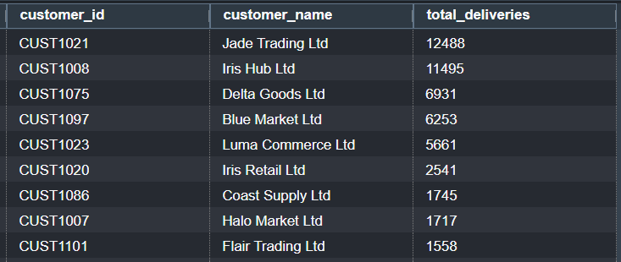
The highest delivery volumes are generated by the same customers producing the highest revenue, indicating a strong positive relationship between delivery activity and revenue generation.

Business question 2
Query 8: Overall Incident Rate
UrbanShift recorded 22.81% of deliveries with an associated incident. This means approximately one in every four deliveries experiences some form of operational issue.
Although the majority of deliveries are completed successfully, the incident rate suggests operational performance should be a key focus area.

Query 9: Incident Rate by City
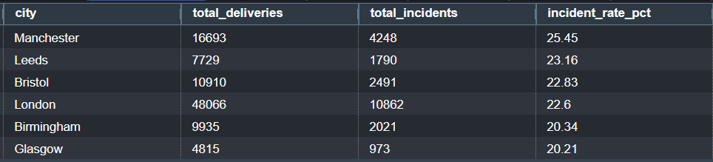
Manchester records the highest incident rate (25.45%), followed by Leeds (23.16%) and Bristol (22.83%). London, despite processing significantly more deliveries, records a slightly lower incident rate (22.60%).
This suggests operational risk is not directly proportional to delivery volume and may instead be influenced by local operational factors.

Query 10: Incident Rate by employment Type
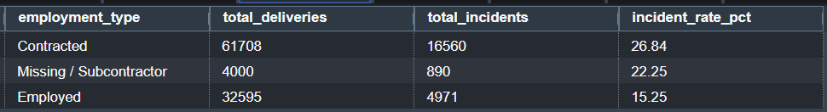
Contracted couriers recorded the highest incident rate (26.84%), considerably higher than employed couriers (15.25%). Deliveries without an assigned courier ID (subcontractors) recorded an intermediate incident rate of 22.25%.
This suggests employment type may have a significant influence on operational performance.

Query 11: Incident Rate by Shift Pattern
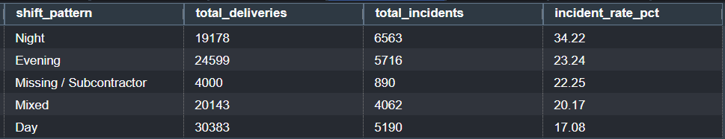
Night shifts produced the highest incident rate (34.22%), almost double the incident rate observed during day shifts (17.08%).
This represents one of the strongest operational findings within the analysis and indicates shift pattern is strongly associated with operational risk.

Query 12: Incident Type Distribution
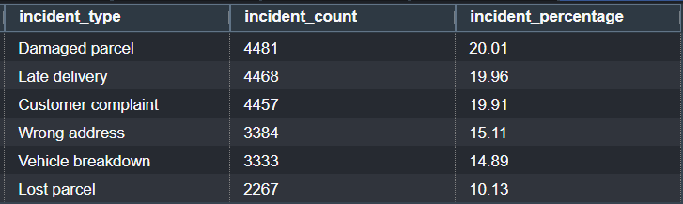
Damaged parcels (20.01%), late deliveries (19.96%) and customer complaints (19.91%) account for approximately 60% of all recorded incidents.
Rather than one dominant operational issue, UrbanShift appears to experience several equally significant service challenges.

Query 13: Resolution Status Analysis
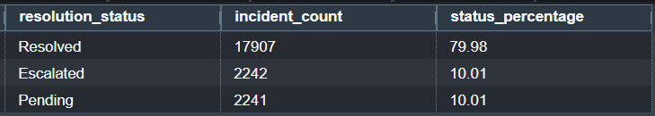
Approximately 80% of incidents have been resolved, while around 10% remain pending and a further 10% have been escalated.
Overall incident resolution appears effective; however, unresolved incidents still represent a considerable operational workload.

Query 14: Incident Type by Resolution Status
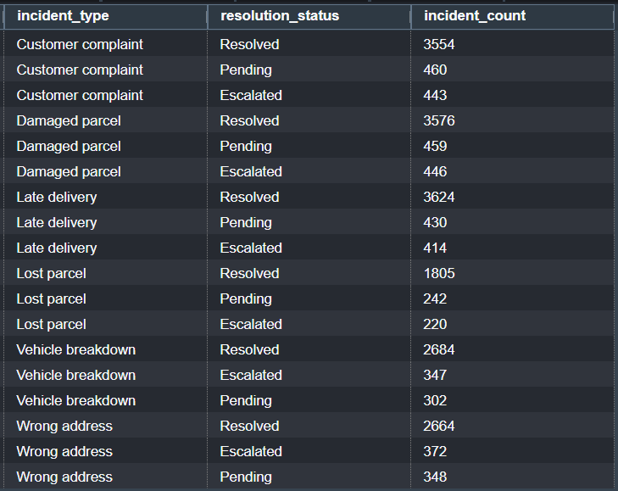
Customer complaints and damaged parcels account for the largest numbers of pending and escalated incidents, although all incident categories display similar resolution patterns.
This suggests incident management processes are generally consistent across incident types.

Query 15: Failed Delivery Rate
Failed deliveries account for 5.01% of all deliveries.
Although relatively low, this still represents almost 5,000 unsuccessful delivery attempts across the analysis period.

Query 16: Returned Delivery Rate
Returned deliveries account for 2.99% of all deliveries.
This indicates returns represent a smaller operational issue than failed deliveries but still contribute additional handling costs.

Query 17: Delivery Time by Delivery Status
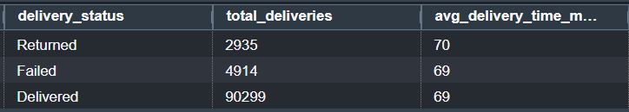
Average delivery time remains almost identical across delivered, failed and returned deliveries (approximately 69–70 minutes).
This suggests delivery duration alone does not explain differences in delivery outcomes.

Query 18: Delivery Time vs Incident Occurrence
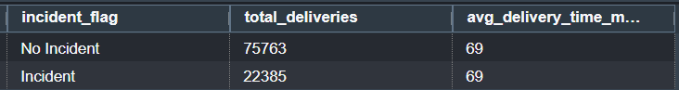
Average delivery duration is identical for deliveries with and without incidents (69 minutes).
Based on this analysis, delivery time does not appear to be a major contributor to operational incidents.

Business Question 3
Query 19: Monthly Delivery Volume by Customer
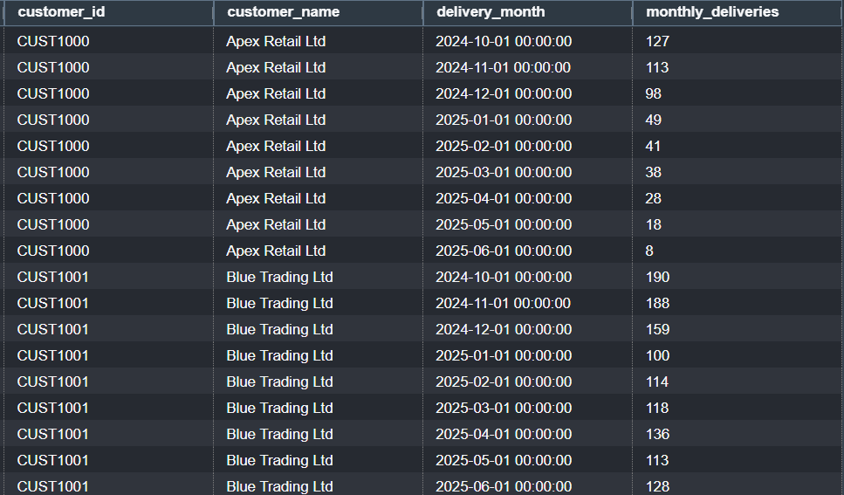
Several customers show sustained declines in delivery activity over the analysis period. For example, Apex Retail Ltd decreased from 127 deliveries in October to 8 in June (approximately 94% decline), whereas Blue Trading Ltd recovered after a temporary decrease. This suggests sustained declines are a stronger indicator of potential churn than short-term fluctuations.

Query 20: Monthly Revenue Trend by Customer
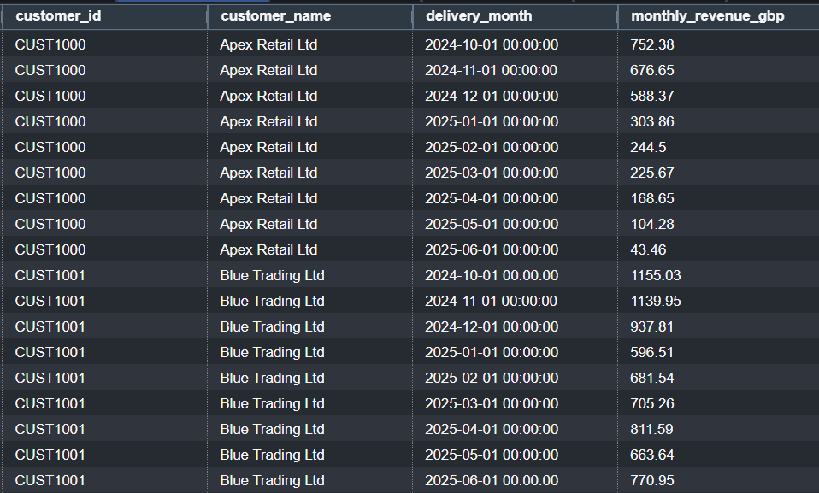
Revenue trends closely mirror delivery volumes. Apex Retail Ltd's monthly revenue declined from £752.38 to £43.46 (approximately 94% decline), while Blue Trading Ltd recovered after an initial decrease. Customers showing consistent reductions in both revenue and activity are likely to represent higher churn risk.

Query 21: Customer Incident Rate
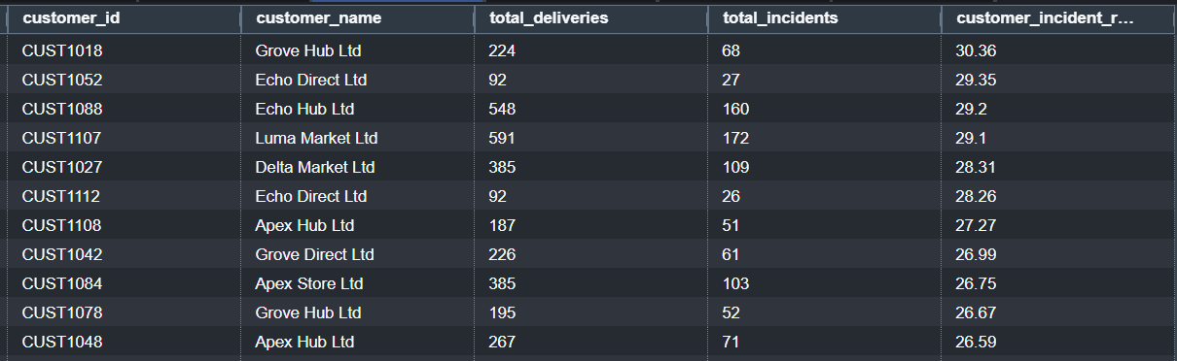
The highest customer incident rates range from 26.35% to 30.36%, exceeding the company average of 22.81%. High-volume customers such as Echo Hub Ltd (29.20%) and Luma Market Ltd (29.10%) experience frequent service disruptions, increasing the risk of customer dissatisfaction.

Query 22: Customer Failed Delivery Rate
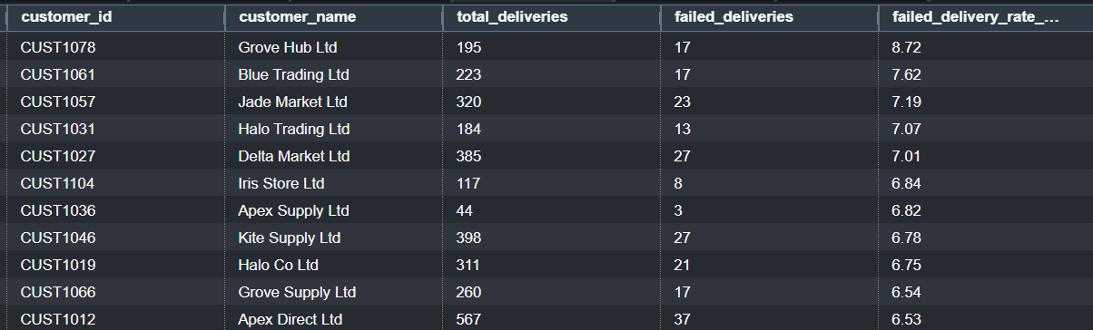
The highest failed delivery rates range between 6.53% and 8.72%, above the company average of 5.01%. Grove Hub Ltd recorded the highest failed delivery rate (8.72%), suggesting delivery reliability may be contributing to reduced customer satisfaction.

Query 23: Customer Service Quality vs Activity
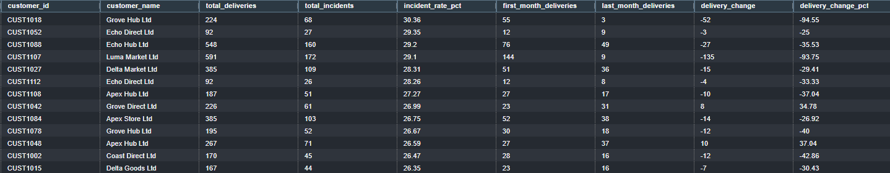
Customers with high incident rates also demonstrate significant reductions in delivery activity. For example, Grove Hub Ltd recorded an incident rate of 30.36% alongside a 94.55% reduction in deliveries, while Luma Market Ltd experienced a 29.10% incident rate and a 93.75% decline. This suggests poor service quality may be linked to declining customer engagement.

Query 24: Churn Model Feature Exploration
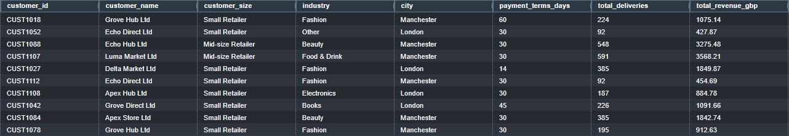
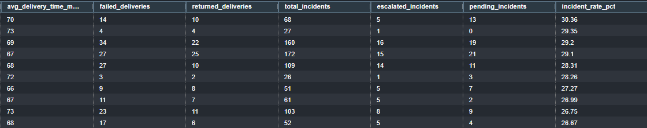

Operational Risk Dashboard
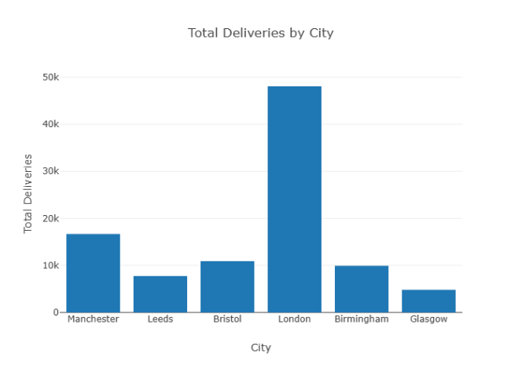
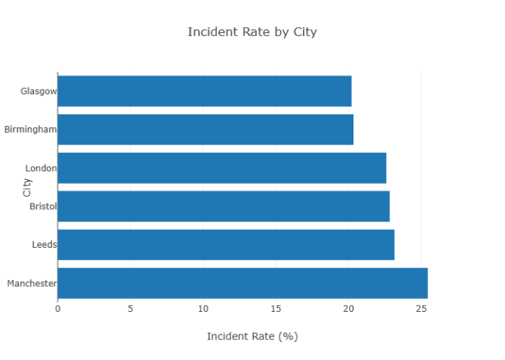
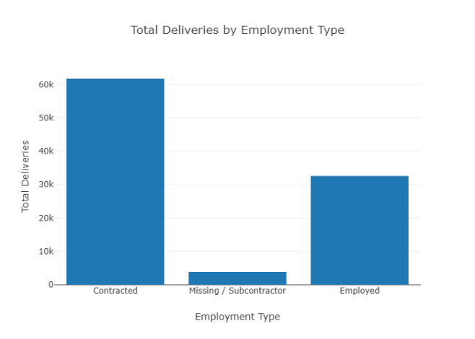
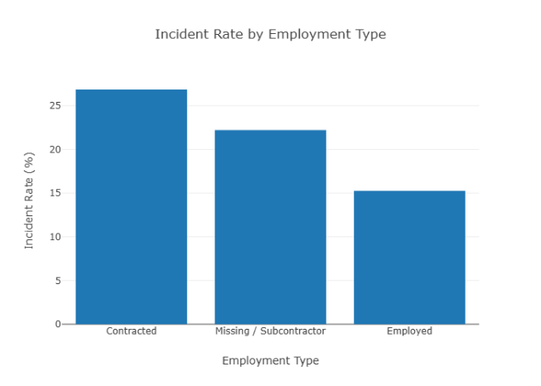
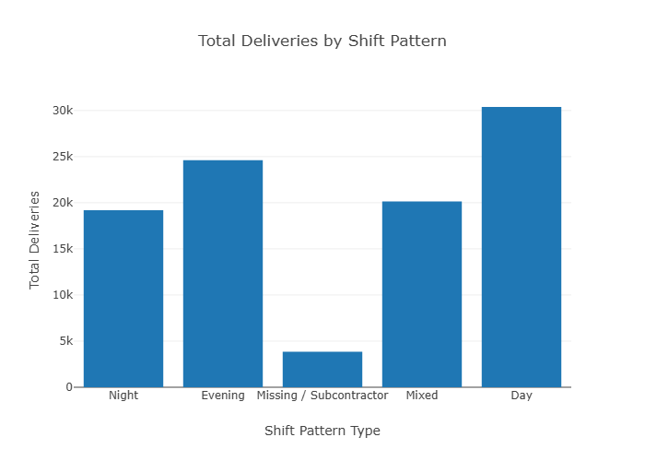
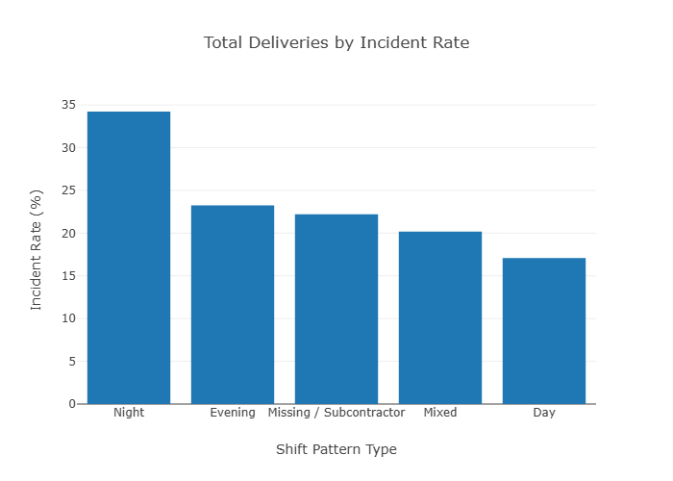
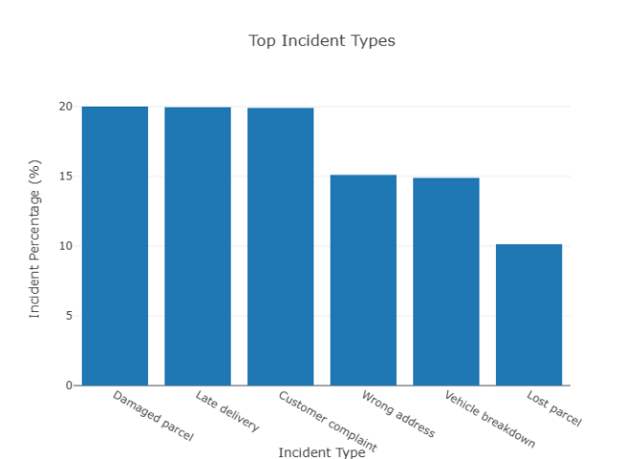
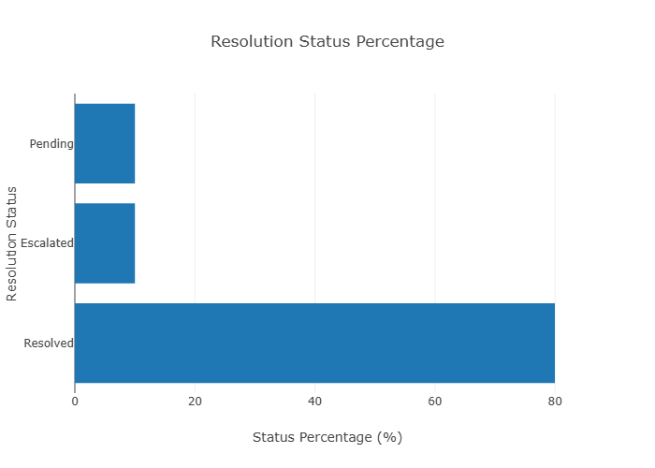
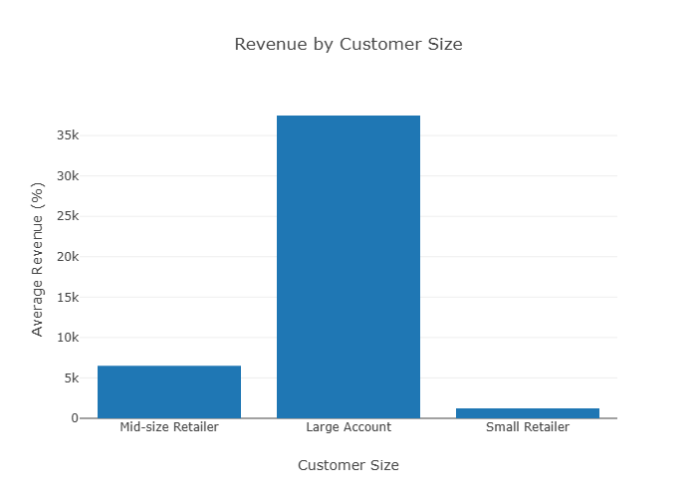
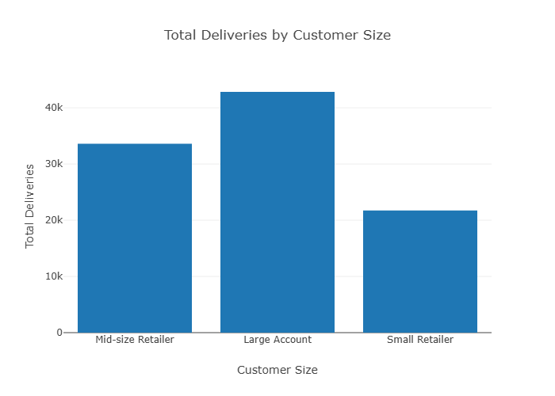
- Revenue by industry – bar chart
  - May reveal opportunities for future growth and customer acquisition.
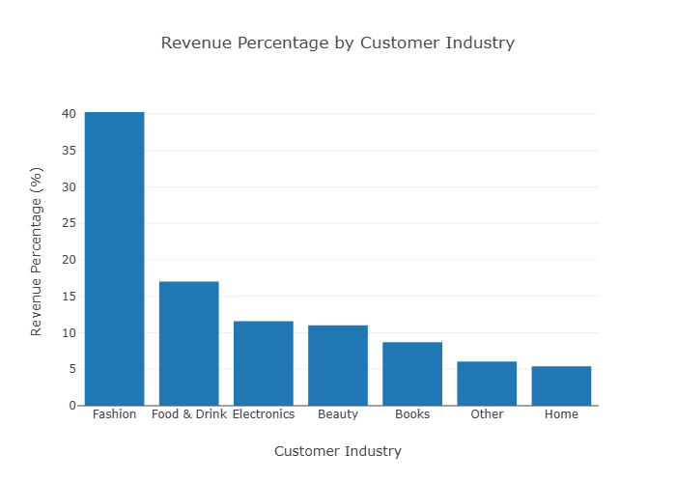
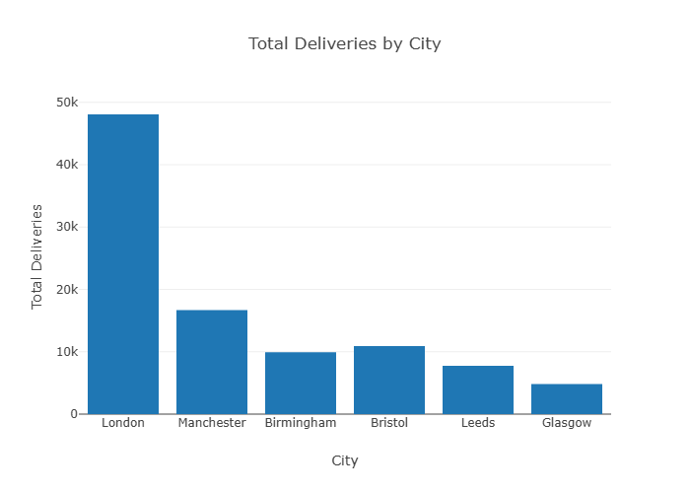
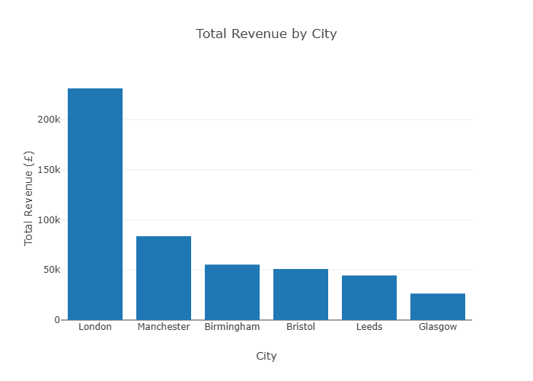

Retention Dashboard
- Monthly deliveries per customer – line chart
  - May provide early indicators of customer churn.
- Monthly revenue by customer
  - Supports churn analysis and customer retention efforts.
- Monthly incidents per customer – line chart
  - May identify customers at increased risk of dissatisfaction or churn.
- Churn risk scores – bar chart
  - Provides an actionable output for stakeholders.

Cleaning Validation
